CS-C3170 - Web Software Development

Course Project – WeCare Application

**Documentation**

Haibi Peng 875552

* CREATE TABLE statements needed to create the database used by the application

*//table used to store user info*

CREATE TABLE **users** (

id SERIAL PRIMARY KEY,

email **VARCHAR**(320) NOT NULL,

password **CHAR**(60) NOT NULL

);

*//table used to store report info*

CREATE TABLE **reports** (

id SERIAL PRIMARY KEY,

date DATE,

morning BOOLEAN,

sleepduration **decimal**(2,1),

sleepquality INT,

mgenericmood INT,

night BOOLEAN,

sporttime **decimal**(2,1),

studytime **decimal**(2,1),

eatregnqua INT,

ngenericmood INT,

user_id INTEGER REFERENCES **users**(id)

);

* The address at which the application can currently be accessed

The application can currently be accessed by using the link below:

<https://wsd-project-wecare.herokuapp.com/>

* Guidelines for running the application

1. Running the application by link above: Using Chrome to open the link

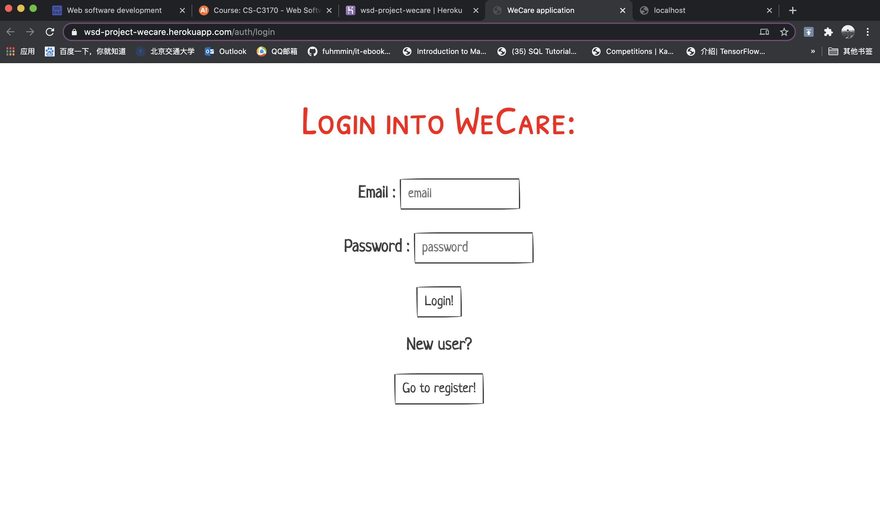

1. Running the application using local host:
2. Using Visual Studio Code to open the application file folder
3. Change the directory of Terminal/CMD/CLI in Visual Studio Code to the directory where the ***app.js*** file lies
4. Start the application by entering the following command and strike enter:

deno run --watch --allow-all --unstable app.js

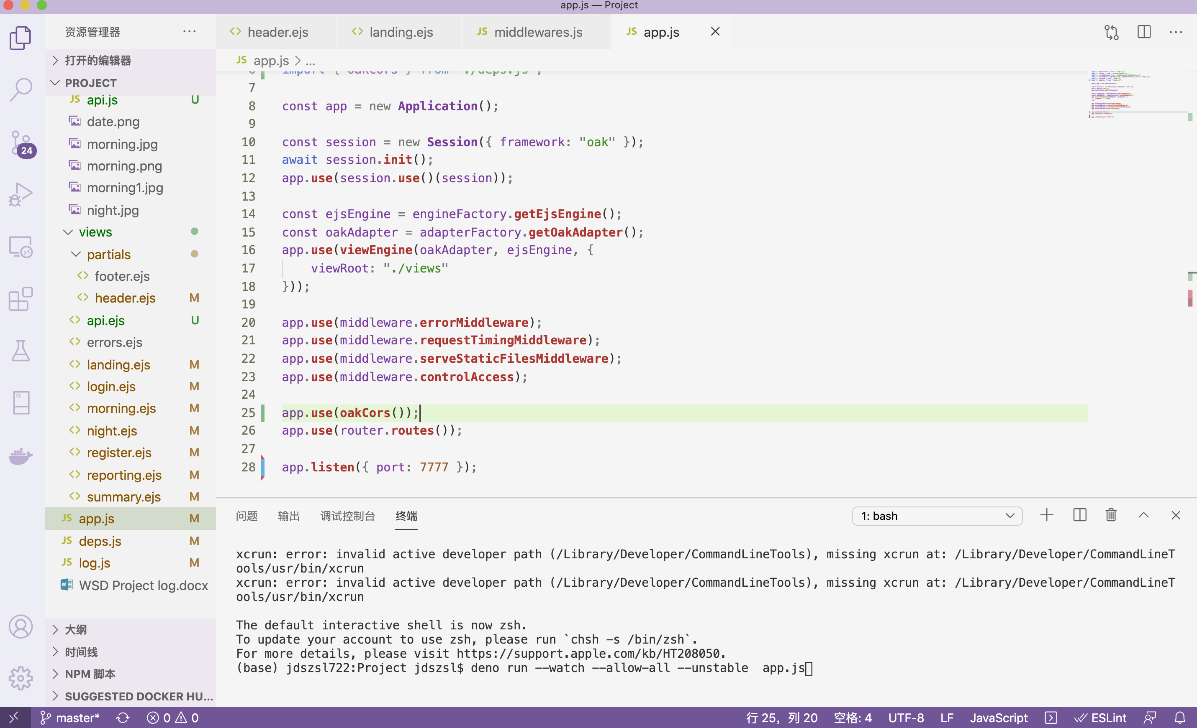

1. Open the application by entering the link below in Chrome:

http://localhost:7777/

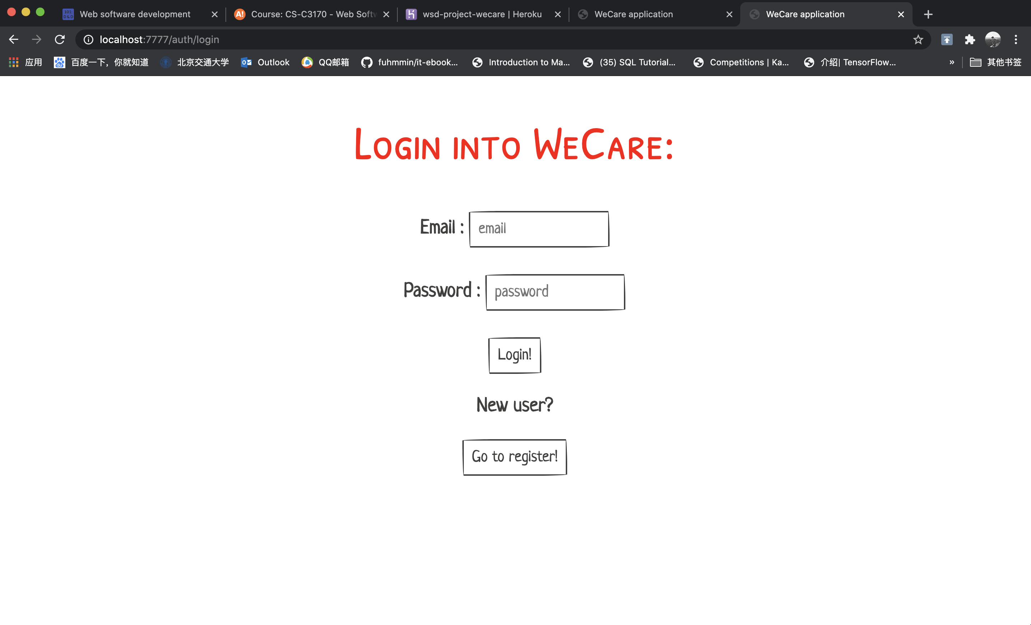

* Guidelines for running tests

1. Using Visual Studio Code to open the application file folder
2. Change the directory of Terminal/CMD/CLI in Visual Studio Code to the directory where you want to run tests
3. Run tests by entering the following command and strike enter:

deno test --allow-all --coverage --unstable xxx_test.js

where xxx_test.js is the test file in the folder

* The functionality for handling duplicate reports

Since morning and night reporting data of one day are in the same line, so there are 3 cases regarding whether the data have been reported.

***In addition to the needed information columns, this application adds two more columns, morning/night (Boolean values, true/false), to record whether the morning and night data have been reported as the creating table statements above.***

When a new reporting is to be stored in the database, we have:

*//To check whether the morning and night data have been reported by using columns* ***date*** *and* ***morning/night***

const morninginfo = await **executeCachedQuery**("SELECT COUNT(*) FROM reports WHERE date=$1 and morning=true and user_id=$2;", data.date, userID);

const nightinfo = await **executeCachedQuery**("SELECT COUNT(*) FROM reports WHERE date=$1 and night=true and user_id=$2;", data.date, userID);

if (morning data reported) {

update the morning data using ‘UPDATE’ in SQL, where morning value does not need change since we already set the morning value as true

} else if (night data reported && morning data not reported) {

update the morning data using ‘UPDATE’ in SQL, where morning value need to be set as true since we do not have the morning data before

} else {

insert the morning data using ‘INSERT’ in SQL, where all the morning reporting values are need

}

And it is the same logic with the night data.